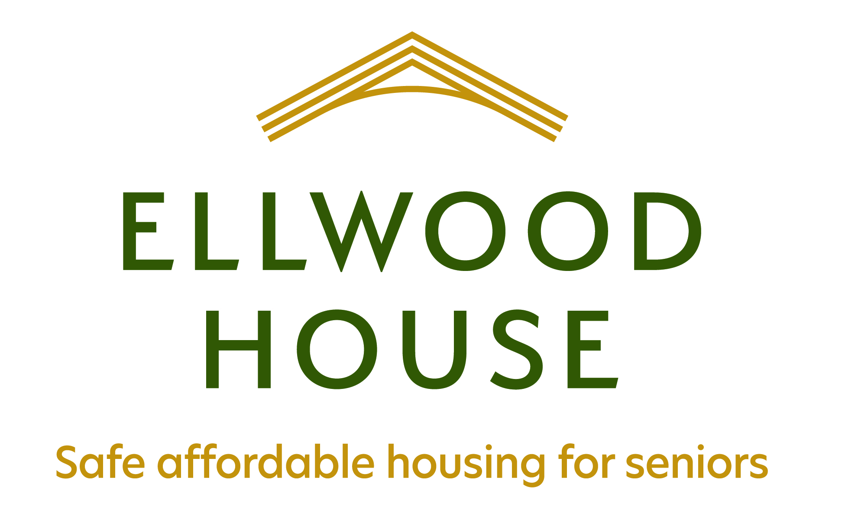

Message from Ellwood House Board of Directors
Many of you will be aware of the ongoing work and discussions in our parish leading to the vision of expanding our Affordable Housing capacity to seniors in our community. Some of you have been more directly involved in the efforts to develop our plans and resources to make this vision a reality. Newcomers to St. Thomas’ Parish will want to understand the background of our ongoing mission to respond to community needs.
In the fall of 2019, the Ellwood House Board of Directors adopted the Ellwood House II Project, and re-named it the Ellwood House Extension. You will learn more about Ellwood House and the plans for developing the Ellwood House Extension from the accompanying Information Briefer, and in the next months through information sessions and other events planned by your Parish Executive.
The extension project responds to the urgent need in our community to provide safe and affordable housing to the many families and individuals who are seeking a home. The project is being led by the Ellwood House Board of Directors, in partnership with the Parish and Diocese. All bring their knowledge, experience and resources to this venture. The extension to Ellwood House is being planned to meet the daily living needs of seniors, built on the program established for our tenant community and in harmony with housing needs identified by our City Planners. As you can understand, these needs have become more urgent in our pandemic environment.
Some of you will recall that the initial vision for future development of Ellwood House imagined a facility that permitted for aging in place and for supportive health care to our tenants. Following investigations into site planning and other considerations, such as financial and legal matters, this plan was not deemed to be feasible at this time. Services in our community have adjusted to meet many of these needs, and new community health programs to support seniors in their homes are being made available through our local Ontario Health Team. We will continue to work with our community health partners to support our tenants.
We will also continue to offer the well-established services at Ellwood House and will be able to meet the increasing need for accessible living through our planned building design. During the information sessions planned in the next months, the Ellwood House Board will provide more information on these plans as they develop.
The Board of Directors of Ellwood House is working in partnership with Cahdco (Community Affordable Housing Development Corporation) and the City of Ottawa to develop this project. We intend to communicate in a timely manner with parishioners and others to enable us to fulfill our commitment to the parish and the community, and to our current and future tenants.

