Images for the Ellwood House Extension

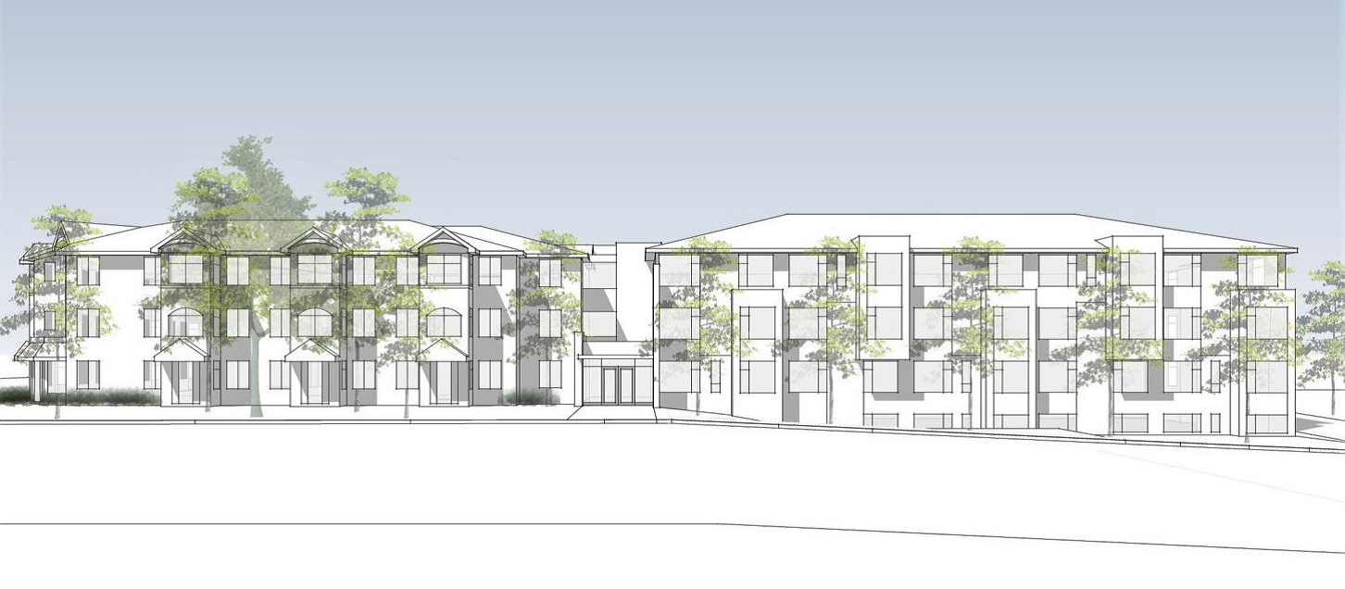

Architect’s concept of the proposed Ellwood House Extension, view from Braeside Avenue (source: Colizza Bruni Architecture)
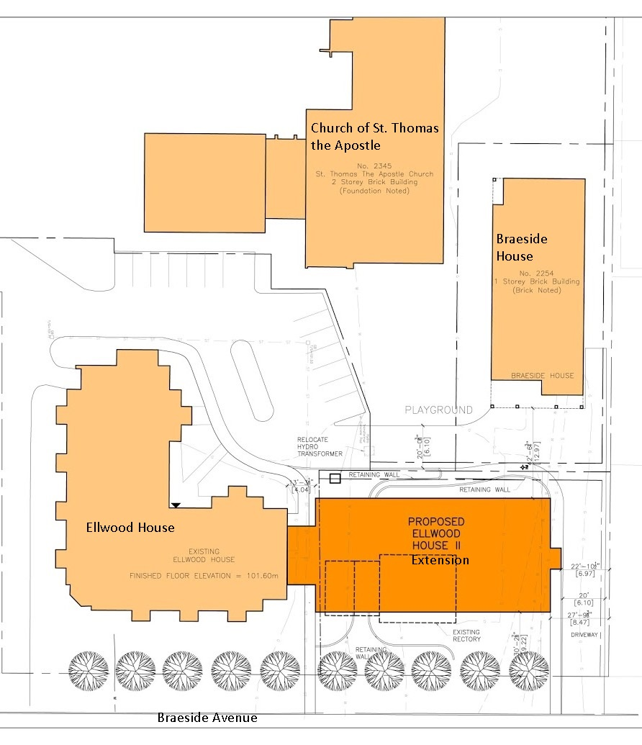
Site plan for the proposed Ellwood House Extension (source: Colizza Bruni Architecture)
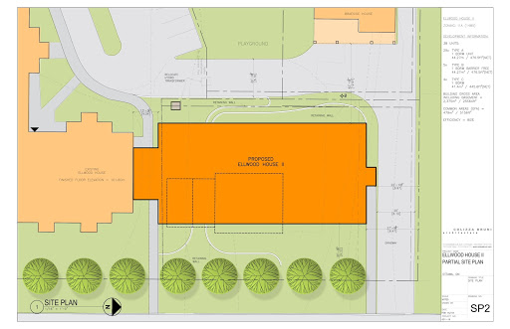
Site plan for the proposed Ellwood House Extension (source: Colizza Bruni Architecture)

