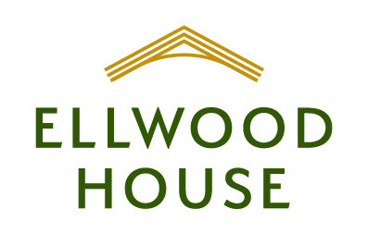
Ellwood House Extension project
Steering committee members

Ellwood House Board of Directors
Janice Horton | President
Larry Doshen | Secretary
Stephen Parks | Treasurer
Michele Bedard | Director
Beverly Ensom | Director
Michael Parkes | Director
David Salisbury | Director
Daniel Warchow | Director

Representing the Church of St. Thomas the Apostle
The Rev.Tim Kehoe | Incumbent
Cathy Munroe | Warden (Parish Executive)

Representing the Anglican Diocese of Ottawa
The Rev. Canon Dr. Peter John Hobbs | Director of Community Ministries

Cahdco Consultant Team
Anna Froehlich | Project Manager and Committee Chair
Billy Cohen | Project Coordinator
Mark Sider | Senior Project Manager

